NAME: MIRUDULA D
REG NO: RA2611026020038
CLASS: CSE AIML

CYBERSECURITY TASK 2 (1st year)
Core Security Concepts Explainer

This document walks through five core cybersecurity concepts using plain, beginner-friendly language and one detailed, concrete real-world scenario for each.
The five concepts covered are: Confidentiality, Integrity, and Availability (the three parts of the CIA Triad), plus two more concepts chosen for this task: Authentication vs. Authorization and Encryption vs. Hashing.

Part 1: The CIA Triad
The CIA Triad is the most basic mental model in all cybersecurity. It is not related to the intelligence agency it stands for three goals that every security system tries to balance:
1)Confidentiality: Keeping information away from people who should not see it.
2)Integrity: Making sure information has not been changed or corrupted, whether accident or on purpose.
3)Availability: Making sure information and services are up and reachable when legitimate people need them.
Almost every security control a company puts in place passwords, backups, firewalls, monitoring exists to protect one or more of these three properties. The three sections below walk through each one individually, with its own real-world scenario and diagram.
1. Confidentiality
Confidentiality means that data is only visible to the people who are supposed to see it. If an unauthorized person an outsider, a hacker, even a nosy coworker can read information they were never meant to access, confidentiality has been broken, even if nothing was changed or deleted.
A term worth defining here: "plain text" means data in its normal, readable form exactly as a human or a program would read it, with no protection applied. "Ciphertext" (or "encrypted data") means that same data has been scrambled using a mathematical process (encryption) so that it looks like random noise to anyone without the correct decryption key.
Real-World Scenario:
Imagine an employee working remotely one afternoon from a coffee shop. He connects to the shop's free public Wi-Fi and logs into his company email account to catch up on messages.
Scenario (A) No protection: The laptop is set up to talk to the mail server using an old, unencrypted connection. Every packet of data including his username and password travels across the coffee shop's Wi-Fi network as plain text. Anyone else connected to that same Wi-Fi network can run a simple, freely available piece of software called a "packet sniffer," which captures data flowing over the network. Because the login data is unencrypted, the attacker's sniffer displays actual username and password on screen, in readable form. The attacker now has permanent access to mailbox and can read every message, past and future, until the password is changed.

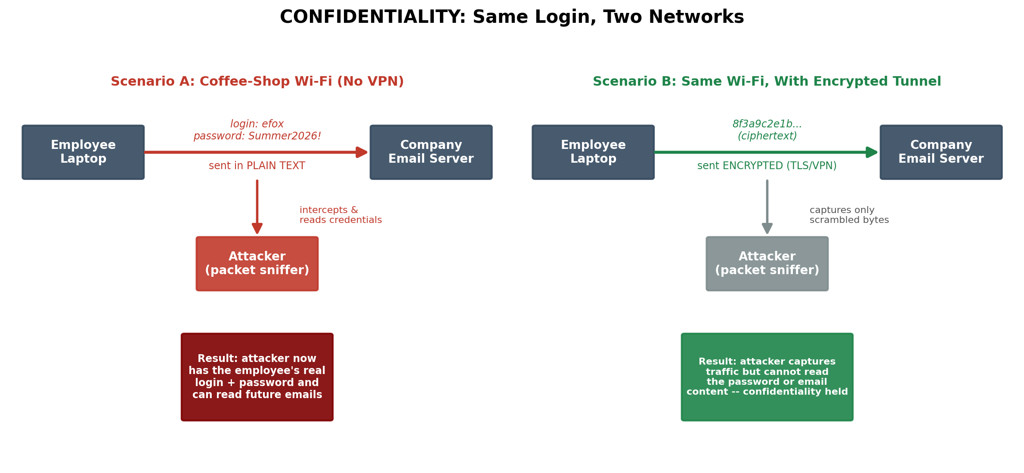

2. Integrity
Integrity means that data can be trusted to be accurate and unaltered what you receive is exactly what was originally sent or stored, with nothing added, removed, or changed along the way, whether by a technical glitch or a deliberate attacker.
A key term here is "hash". A hash is the output of running data through a special one-way mathematical function that produces a short, fixed-length string of characters, unique to that exact input. Changing even a single character of the original data a single digit in a dollar amount, for example produces a completely different hash. This makes a hash useful as a tamper-evident fingerprint: if you re-calculate the hash later and it does not match the original, you know something changed.
Real world scenario:
An accounting clerk sends a wire-transfer request for $1,000 to Vendor X. The message gets a hash to protect its integrity.
An attacker changes the amount to $10,000 while the message is being sent, but cannot create a matching hash. When the bank receives it, the new hash doesn’t match the original, so the system rejects the payment and flags it for review.
This shows how hashing can detect if a message was changed or tampered with. 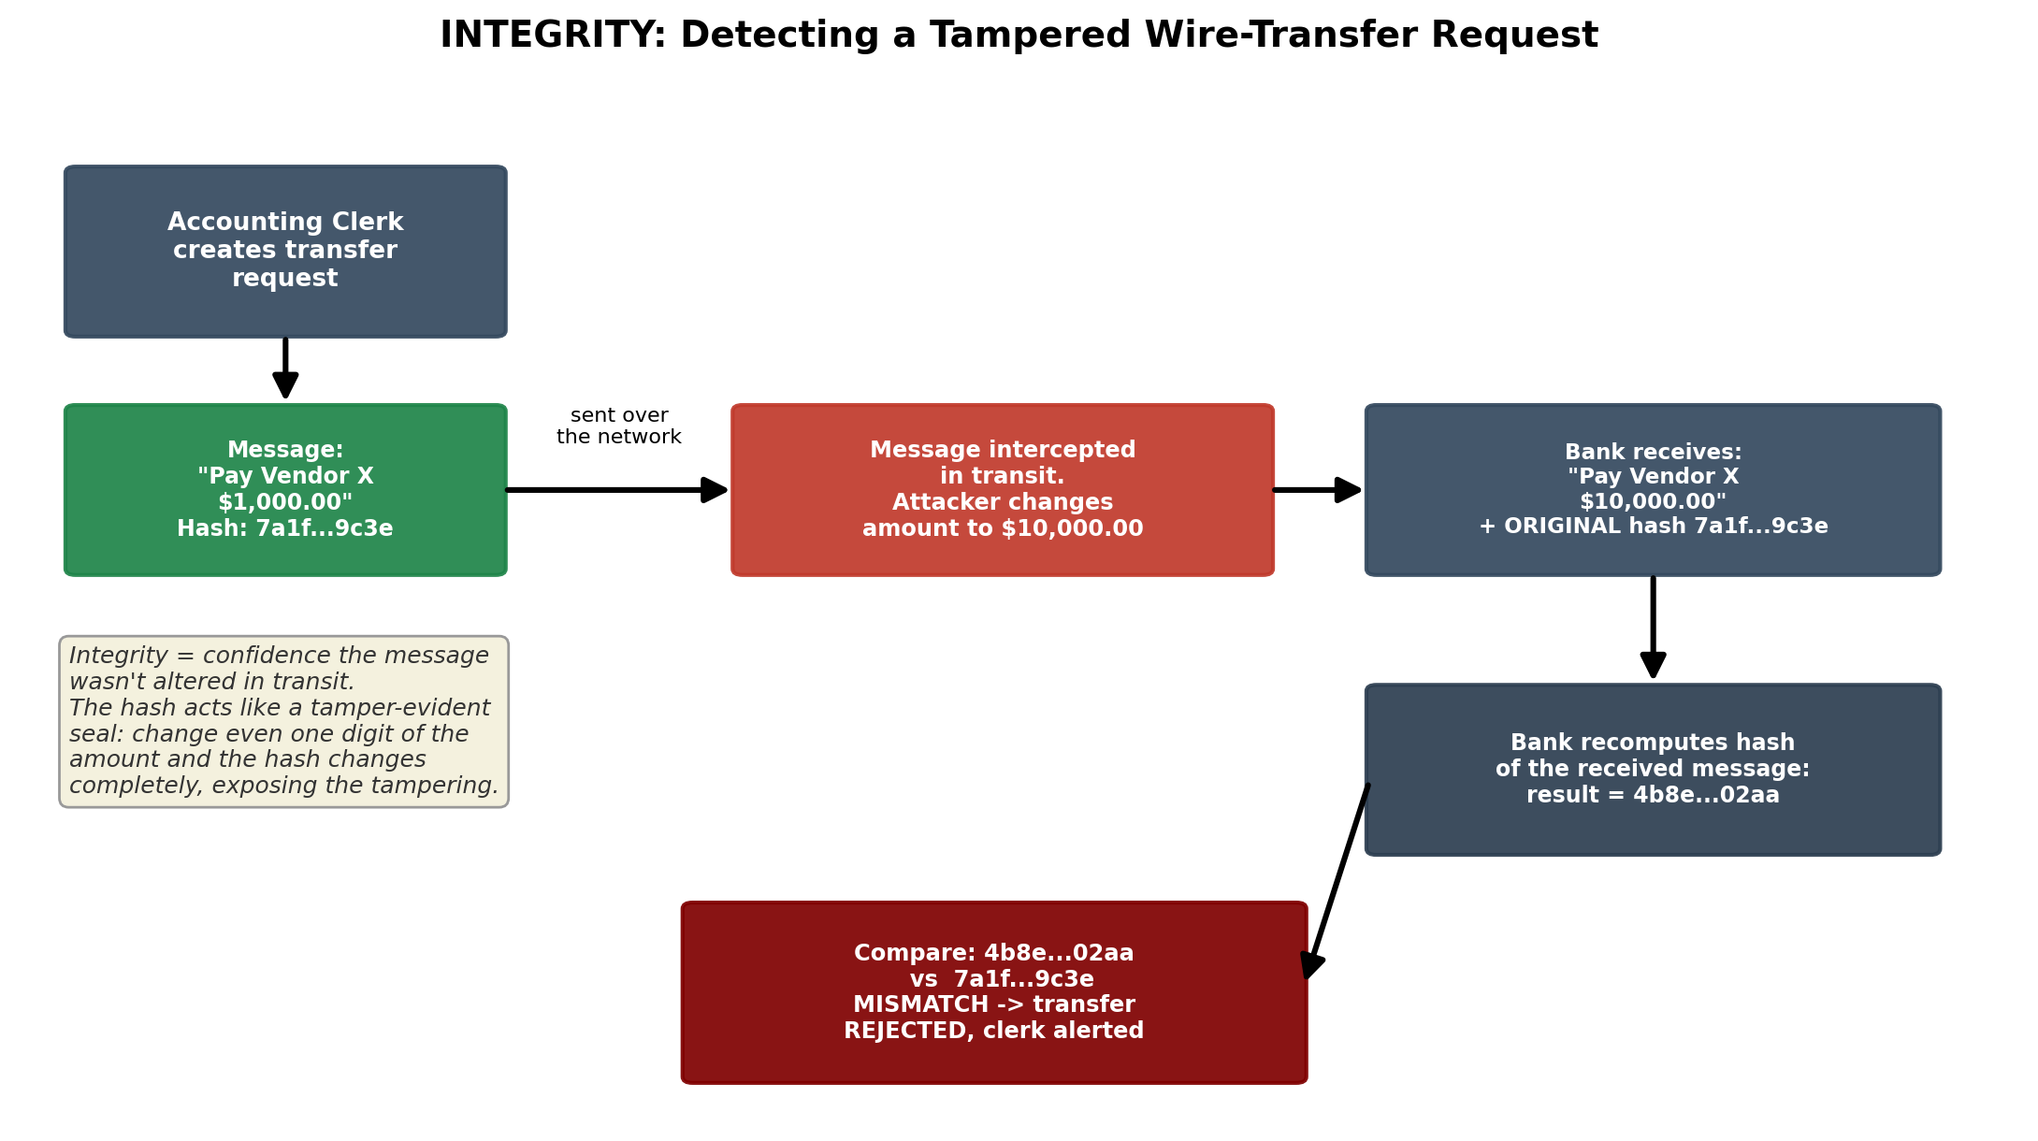

3. Availability
Availability means that systems, data, and services are accessible and working when legitimate users need them. A system can be perfectly confidential and perfectly intact and still be a total security failure if nobody can reach it when it matters.
A relevant term here is "DDoS," short for Distributed Denial-of-Service. This is an attack where an attacker uses many compromised computers scattered across the internet to simultaneously flood a target server with an overwhelming volume of fake traffic or requests, with the goal of exhausting its resources so it can no longer respond to real users.
Real world scenario:
During a major flash sale, a retailer’s server normally handles about 300 requests per second. An attacker launches a DDoS attack with around 200,000 fake requests per second, overwhelming the server.
As a result, genuine customers face slow loading, timeouts, or 503 errors and cannot complete their purchases.
This shows why availability is important in cybersecurity. Attacks like DDoS can make a service unavailable even without stealing or changing any data. Common defenses include CDNs, traffic filtering, and rate limiting.
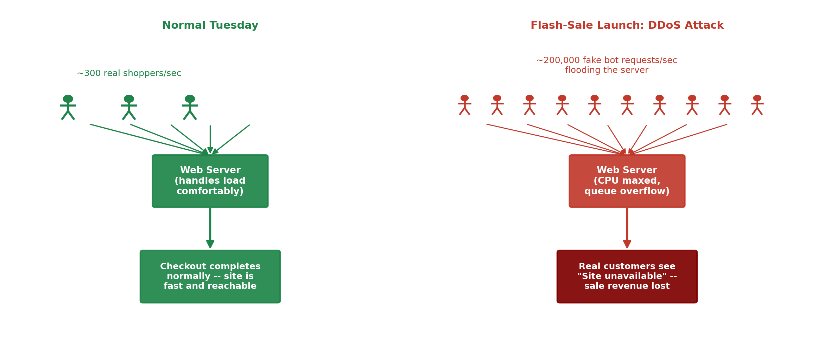
Part 2: Two More Core Concepts
Beyond the CIA Triad, two other pairs of ideas come up constantly in cybersecurity and are frequently confused by beginners. Understanding the difference between each pair is essential to understanding how real systems are secured.
4. Authentication vs. Authorization
These two words sound alike and are often used loosely as if they mean the same thing, but they answer two completely different questions:
- Authentication proves who someone is. It answers the question "are you really who you claim to be?" Common examples include entering a password, scanning a fingerprint, or receiving a one-time code (OTP) by text message.
- Authorization determines what an already-identified person is allowed to do or see. It answers the question "now that I know who you are, what are you permitted to access?"
Critically, authentication always happens first, but successful authentication does not automatically grant unlimited authorization. A system can and usually does know exactly who you are while still refusing to let you do certain things.
Real world scenario:
Priya logs into her company’s HR portal using her username, password, and a one-time code (2FA). This is authentication, which confirms that she is really Priya.
She can view her own pays slips because her HR role allows it. This is authorization.
When she tries to view the CEO’s salary by changing the employee ID, the system denies access with a 403 Forbidden error because she doesn’t have permission.
In short: Authentication verifies who you are, while authorization checks what you are allowed to do. 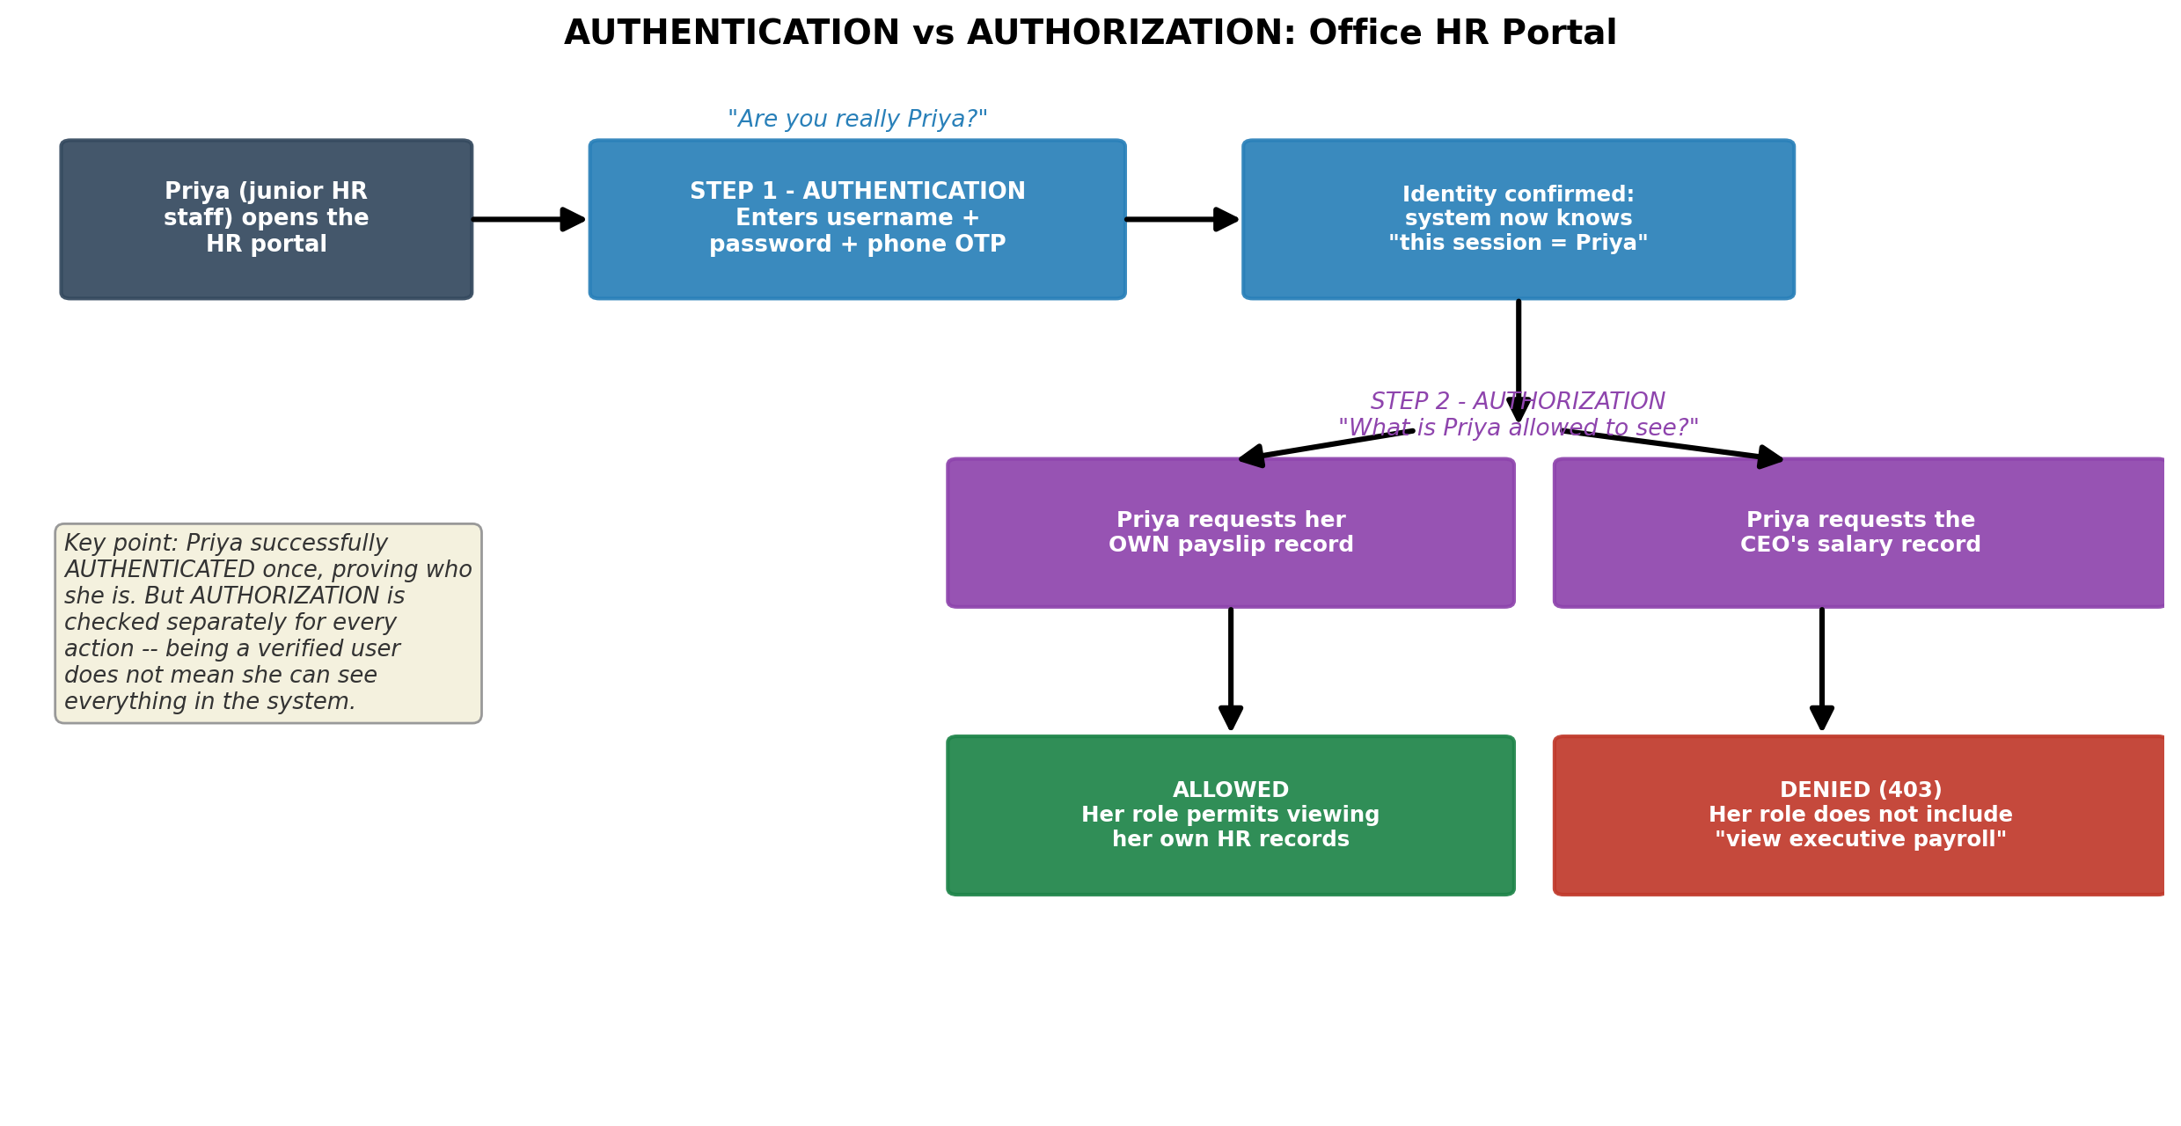

5. Encryption vs. Hashing
Both encryption and hashing take readable data and turn it into something that looks scrambled and unreadable, which is why beginners frequently mix them up. The essential difference is reversibility:
- Encryption: is reversible by design. Data is scrambled using a secret key, and anyone who has that same key can reverse the process and recover the original data exactly. Encryption is used whenever the original data needs to be recovered later.
- Hashing: is one-way by design. Data is run through a hash function to produce a fixed-length digest, but there is no key and no process that turns that digest back into the original data. Hashing is used when you only ever need to check or compare data, never recover it.
Real world scenario:
An online retailer stores credit card numbers using encryption because the original number must be recovered later for payments. Encryption can be reversed using the correct key.
Passwords are stored using hashing because they never need to be recovered. The system hashes the password during login and compares it with the stored hash.
If hackers steal the database and encryption key, they can recover the credit card numbers. Hashed passwords, however, cannot simply be reversed, although attackers may try to guess them. Salting makes these attacks harder.
In short: Use encryption when data needs to be recovered and hashing when it only needs to be verified. 